**Assignment No. 01**



**SUBMITTED BY:**

Haider Ali

**REGISTRATION NO.**

FA21-BEE-053

**SUBMITTED TO:**

Dr. Muhammad Kaleem

**Question 1:**

Write a program that displays the output of

Check = Check++ + Check ++;

Check = ++ Check + ++ Check;

Check = Check ++ + ++ Check;

• Make sure to write meaning full comments.

• Every student will assign a different value to the given variable (Check).

**Ans:**

#include <stdio.h>

int main() // calling of main function

{

int Help = 53 ; // Declaring a variable "check" of data type integer and assigned a value 53 to it.

printf("\nThe first value of check: %d\n", Help); // this command prints the first value of variable 'check' on display.

Help = Help++ + Help++; // this line performs the following action 54+53=107 and then increment this value 107+1=108.

printf("\nThe second value of check: %d\n", Help); // this command prints the second value of variable 'check' on display.

Help = ++Help + ++Help; // this line performs following action 109+109 = 218.

printf("\nThe third value of check: %d\n", Help); // this command prints the third value of variable 'check' on display.

Help = Help++ + ++Help; //this line perform following action 219+219 = 438.

printf("\nThe fourth value of check: %d\n", Help); // this command prints the fourth value of variable 'check' on display.

return 0; // it shows program executes successfully.

}

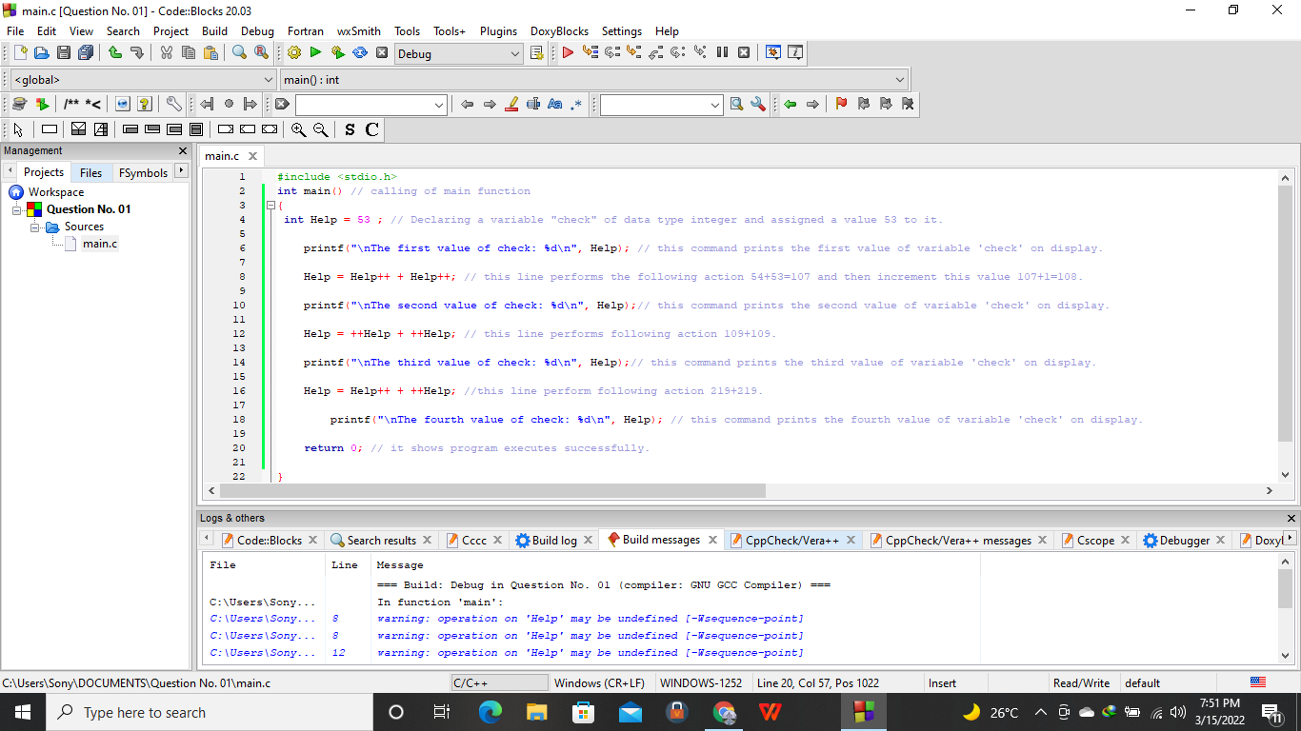

**Output:**

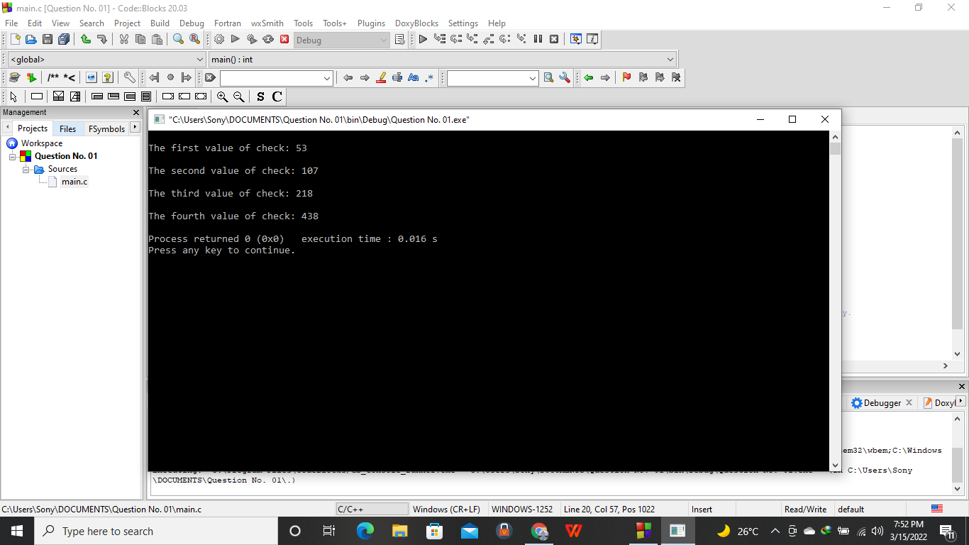

**Question No. 02:**

**Ans:**

**Syntax:**

* The syntax of a programming language is a collection of rules to specify the structure or form of code.

**Semantics:**

* Semantics refers to the interpretation of the code or the associated meaning of the symbols, characters or any part of a program.

**SRAM**/**DRAM:**

* SRAM is an on-chip memory whose access time is small while DRAM is an off-chip memory which has a large access time. Therefore SRAM is faster than DRAM. DRAM is available in larger storage capacity while SRAM is of smaller size. SRAM is expensive whereas DRAM is cheap.

**Algorithm:**

An algorithm is a step-by-step procedure for solving the problem while programming is a set of instructions for a computer to follow to perform a task. In other Words Algorithm is a well-defined, systematic logical approach that comes with a step-by-step procedure for computers to solve any given program.

**Program:**

A program could also be an implementation of code to instruct a computer on how to execute an algorithm. In other words it refers to the code (written by programmers) for any program that follows the basic rules of the concerned programming language.

**Question 3:**

Write a program that reads in the radius of a circle as an integer and

Prints the circle’s diameter, circumference and area. Use the constant

Value 3.14159 for π.

**Ans:**

#include <stdio.h> // Preprocessor directives.

int main() // calling of main function.

{

int radius; // decleration of integer of data type radius.

float area; // decleration of float of data type area.

float circumference; // decleration of float of data type circumference.

int diameter; // decleration of integer of data type diameter.

printf("\nEnter Radius of Circle:"); // Giving message to the user.

scanf("%d", &radius); // Taking input from the user.

area = 3.14159 * radius * radius; // writing the formula for area.

printf("\narea of circle: %f \n" , area); // Giving message to the user for area of circle to display.

circumference = 2 * 3.14159 * radius; // writing the formula for circumference.

printf("\ncircumference of circle: %f\n" , circumference); // Giving message to the user for circumference of circle to display.

diameter = 2 * radius; // Writing the formula for diameter.

printf("\nDiameter of circle: %f\n", diameter); // Giving message to the user for diameter of circle to display.

return 0; // it show program executes successfully.

}

// used for ending of program.

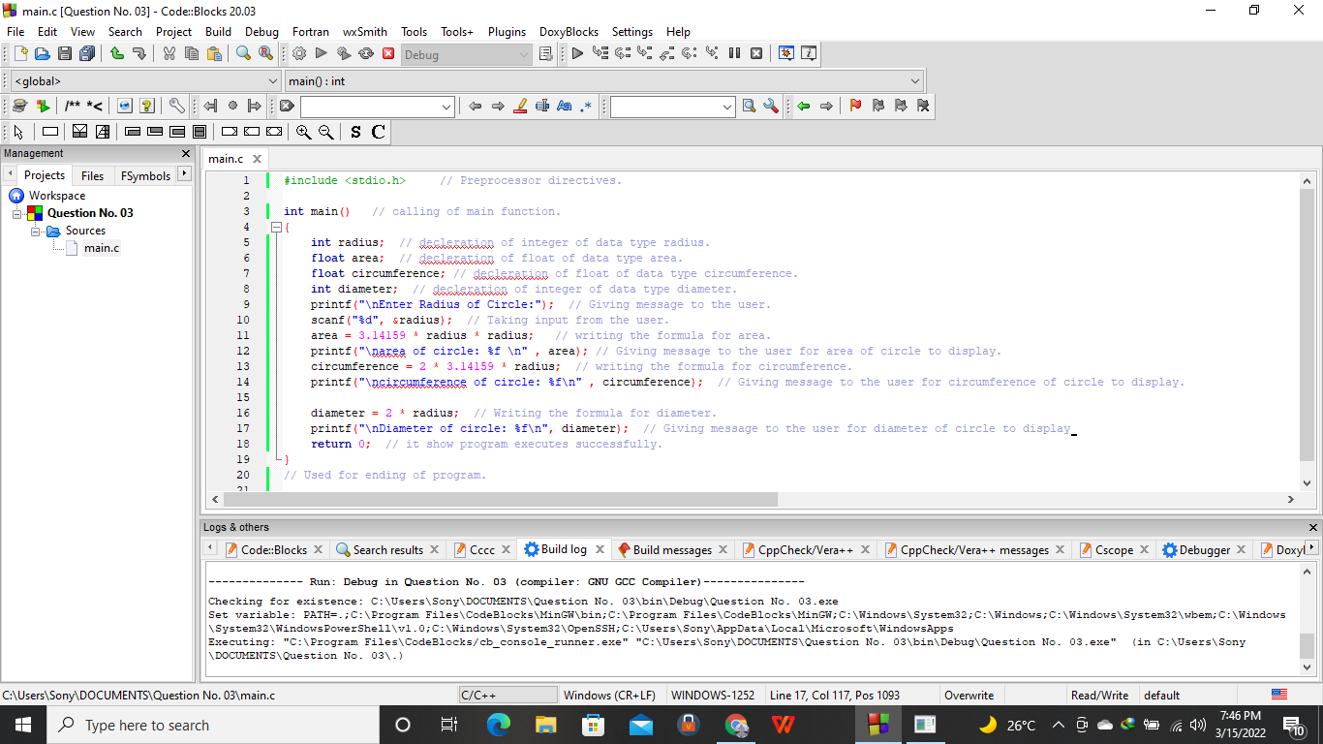

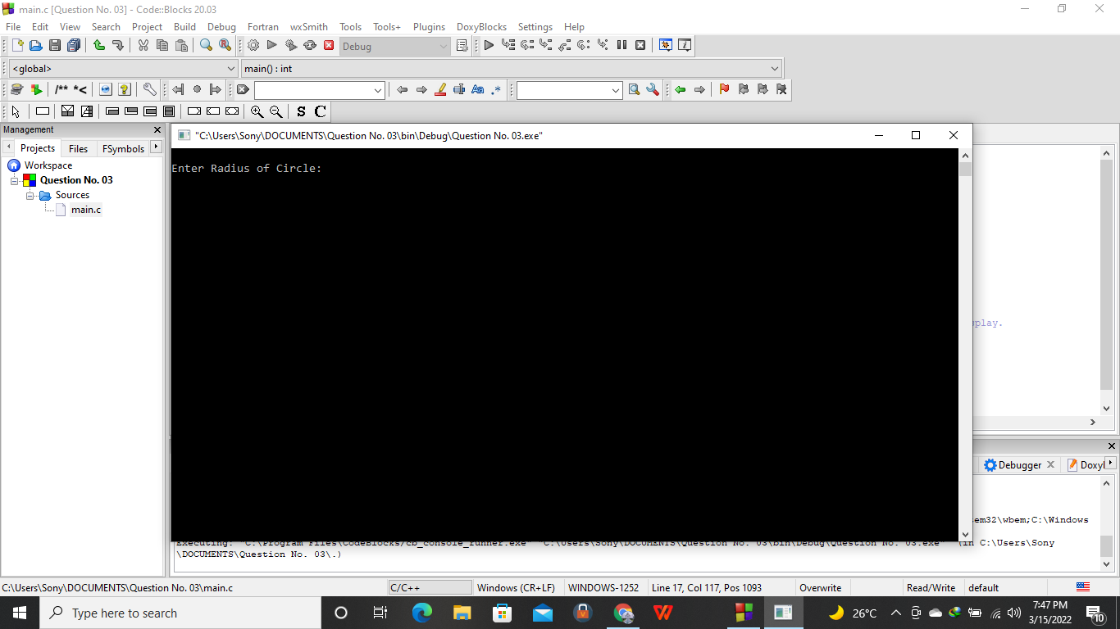

**OUTPUT:**

